

**ECEN 5053-003 Homework Assignment**

Course Name: Embedding Sensors and Actuators

Corresponding Module: C3M4

Week Number: 12

Module Name: Motion, Distance, and Humidity Sensors

Note: Correct answer is in Blue Font

Submitted By: Poorn Mehta

Part 1: Each question is worth 9 points.

1. Answer the following questions about PIR Motion detectors.

A.1 What are pyroelectric materials?

Answer: **Pyroelectricity is the ability of certain materials to generate an electrical potential when they are heated or cooled**. As a result of this change in temperature, **positive and negative charges move to opposite ends through migration** (i.e. the material becomes polarized) and hence, an **electrical potential is established**. Pyroelectricity can be visualized as one side of a triangle, where each corner represents energy states in the crystal: kinetic, electrical and thermal energy. The side between electrical and thermal corners represents the pyroelectric effect and produces no kinetic energy. The side between kinetic and electrical corners represents the piezoelectric effect and produces no heat. **The materials which exhibit Pyroelectricity – are known as Pyroelectric Materials** [**[1]**](https://www.sciencedaily.com/terms/pyroelectricity.htm)**.**

A.2 What problem do you encounter in designing a motion detector because all pyroelectric materials are also piezoelectric? How do you resolve this problem?

Answer: In motion detectors, since the materials being used are also piezoelectric, **even the small vibrations will generate some electrical voltage which acts as a noise on the output**. To **prevent** this, the **motion detector is mounted in a way** that it has the **least possibility of getting vibrations**. Additionally, it uses a specific lens arrangement – known as **Fresnel Lens** – which works as an **optical amplifier**. It **takes in more IR radiation, and also focuses to the small sensitive area to maximize the output due to actual motion**. This reduces the error to a great extent [**[2]**](https://learn.adafruit.com/pir-passive-infrared-proximity-motion-sensor/how-pirs-work) .

A.3 What is the difference between primary and secondary pyroelectricity?

Answer: [**[3]**](http://www.ph.unimelb.edu.au/~daewe/sensors/prot/lectures/lecture05.pdfhttp:/www.ph.unimelb.edu.au/~daewe/sensors/prot/lectures/lecture05.pdf)

**Primary Pyroelectricity**: In this, **temperature changes shortens or elongates individual dipoles**. This **affects randomness of dipole orientations** due to thermal agitation.

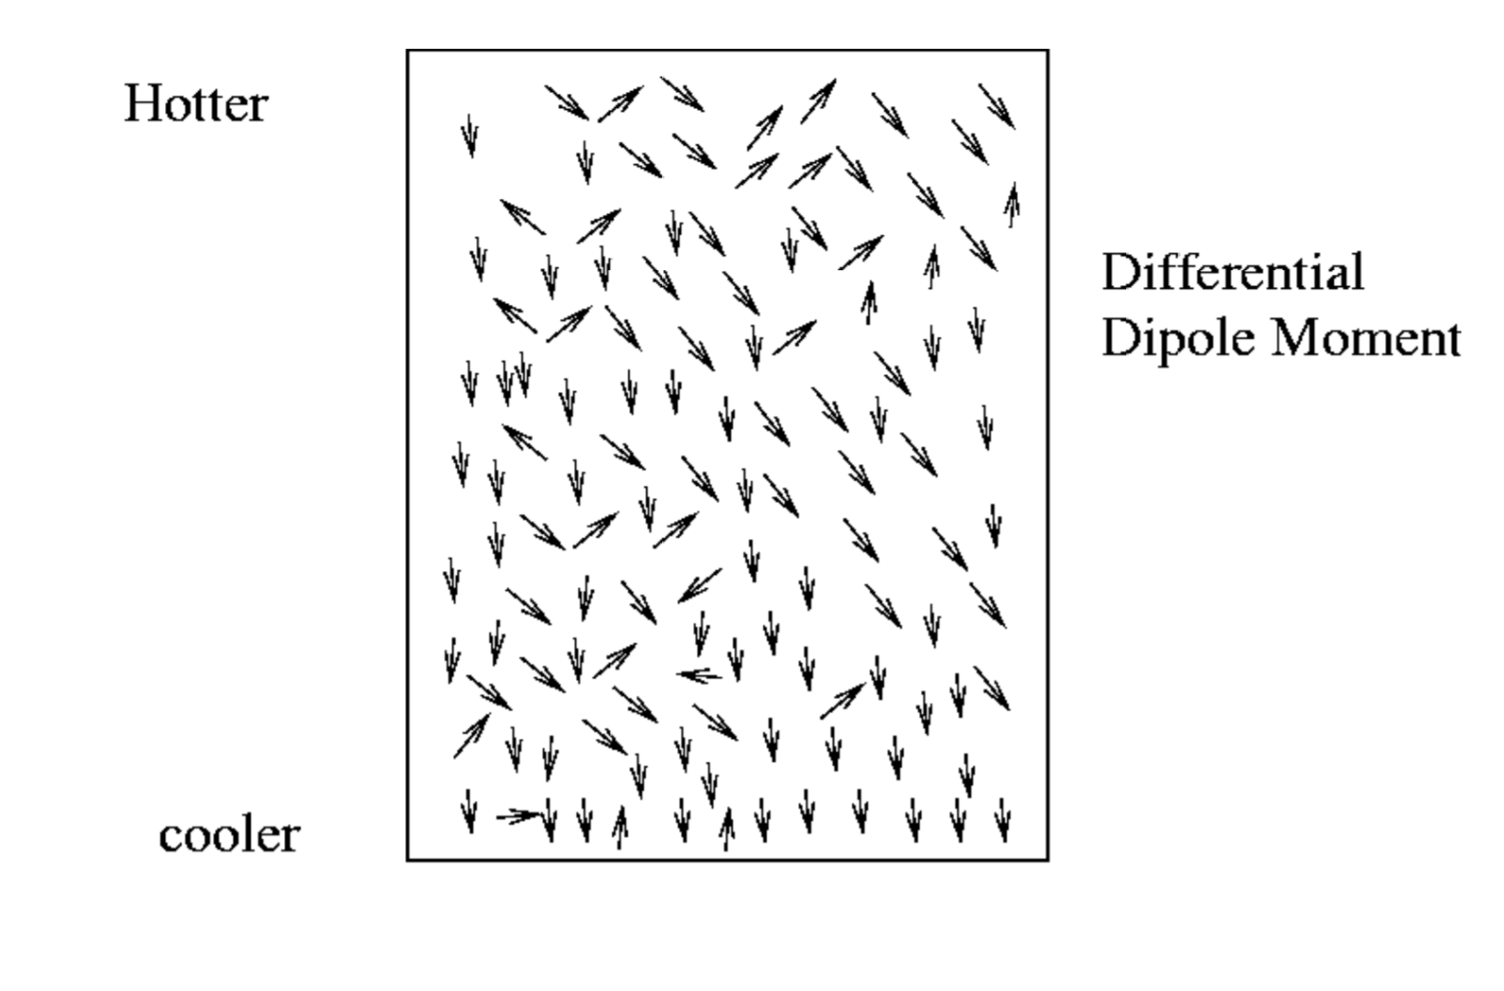

**Secondary Pyroelectricity**: In this, the change/**differential temperature change induces strain**. Which is **the reason for piezoelectricity behavior of every pyroelectric material.**

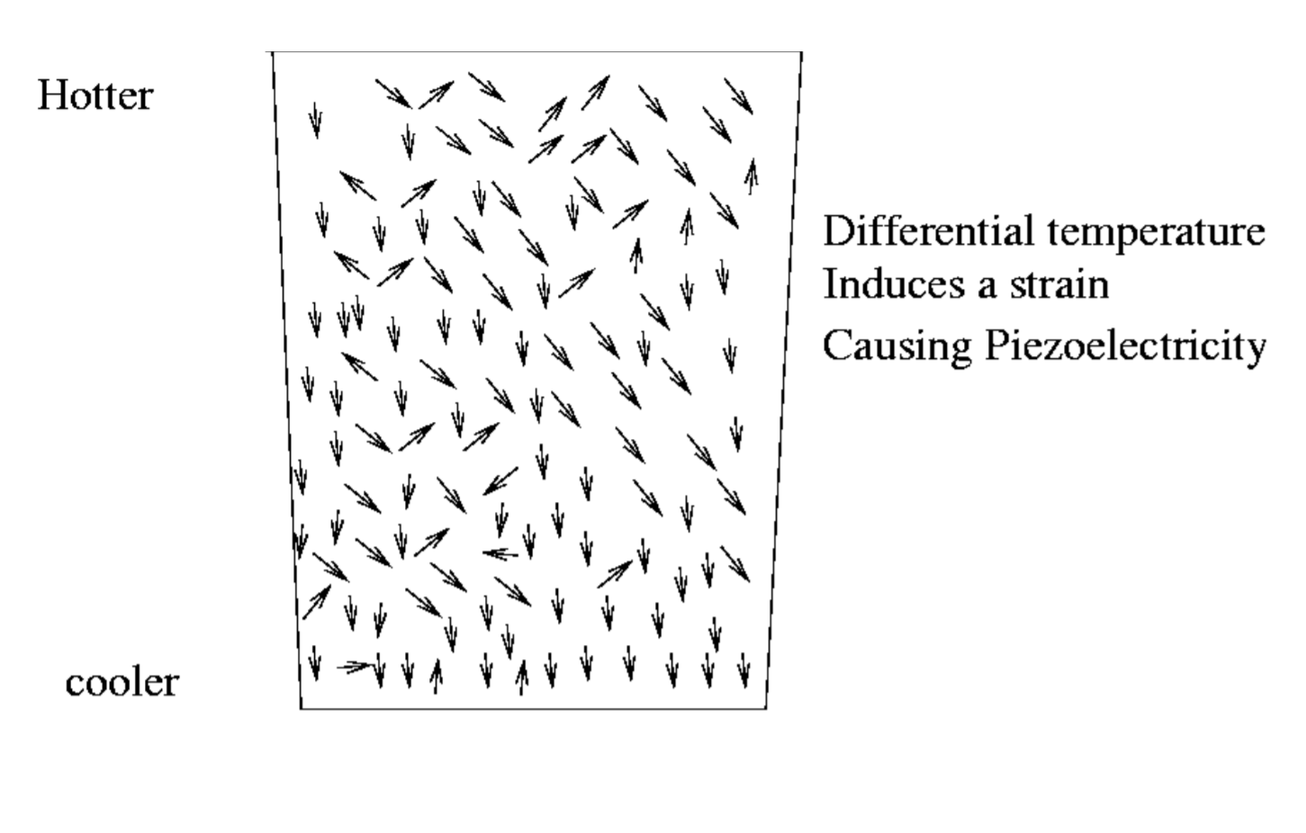

A.4 What happens to the pyroelectric effect in a material at the Curie point?

Answer: For the pyroelectric material, the **polarization falls to zero when approaching the Curie Point**. Also, the **electron mobility is changed at the Curie Temperature**. This will **result in very high resistivity** in some specific materials [**[4]**](https://www.sciencedirect.com/topics/materials-science/pyroelectric-material) .

A.5 What is the difference between the Pyroelectric charge coefficient PQ and the pyroelectric voltage coefficient PV?

Answer: [**[5]**](http://www.ph.unimelb.edu.au/~daewe/sensors/prot/lectures/lecture05.pdfhttp:/www.ph.unimelb.edu.au/~daewe/sensors/prot/lectures/lecture05.pdf)

Pyroelectric Charge Coefficient **PQ**: **Ratio of change of spontaneous polarization to the change of Temperature.**

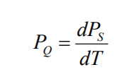

Pyroelectric Voltage Coefficient **PV**: **Ratio of change of electric field to the change of Temperature.**

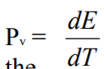

A.6 Why is PbTiO3 a popular ceramic to use in practical applications for pyroelectric crystals?

Answer: PbTiO3 is widely used because one of its characteristics is to have **a relatively higher Pyroelectric Coefficient over a vast range of temperature change**. Therefore, **it can be easily used for applications requiring reliable operation over a big operating temperature range** [**[6]**](http://citeseerx.ist.psu.edu/viewdoc/download?doi=10.1.1.895.2231&rep=rep1&type=pdf) .

A.7 How does a differential PIR detector circuit work?

Answer: The PIR sensor itself has **two slots** in it, each slot is made of a special material that is sensitive to IR. The lens used here is not really doing much and so we see that the two slots can 'see' out past some distance (basically the sensitivity of the sensor). When the sensor is idle, both slots detect the same amount of IR, the ambient amount radiated from the room or walls or outdoors. **When a warm body** like a human or animal **passes by, it first intercepts one half of the PIR sensor, which causes a positive differential change** between the two halves. **When the warm body leaves the sensing area**, the reverse happens, whereby **the sensor generates a negative differential change. These change pulses are what is detected** [**[7]**](https://learn.adafruit.com/pir-passive-infrared-proximity-motion-sensor?view=all) .

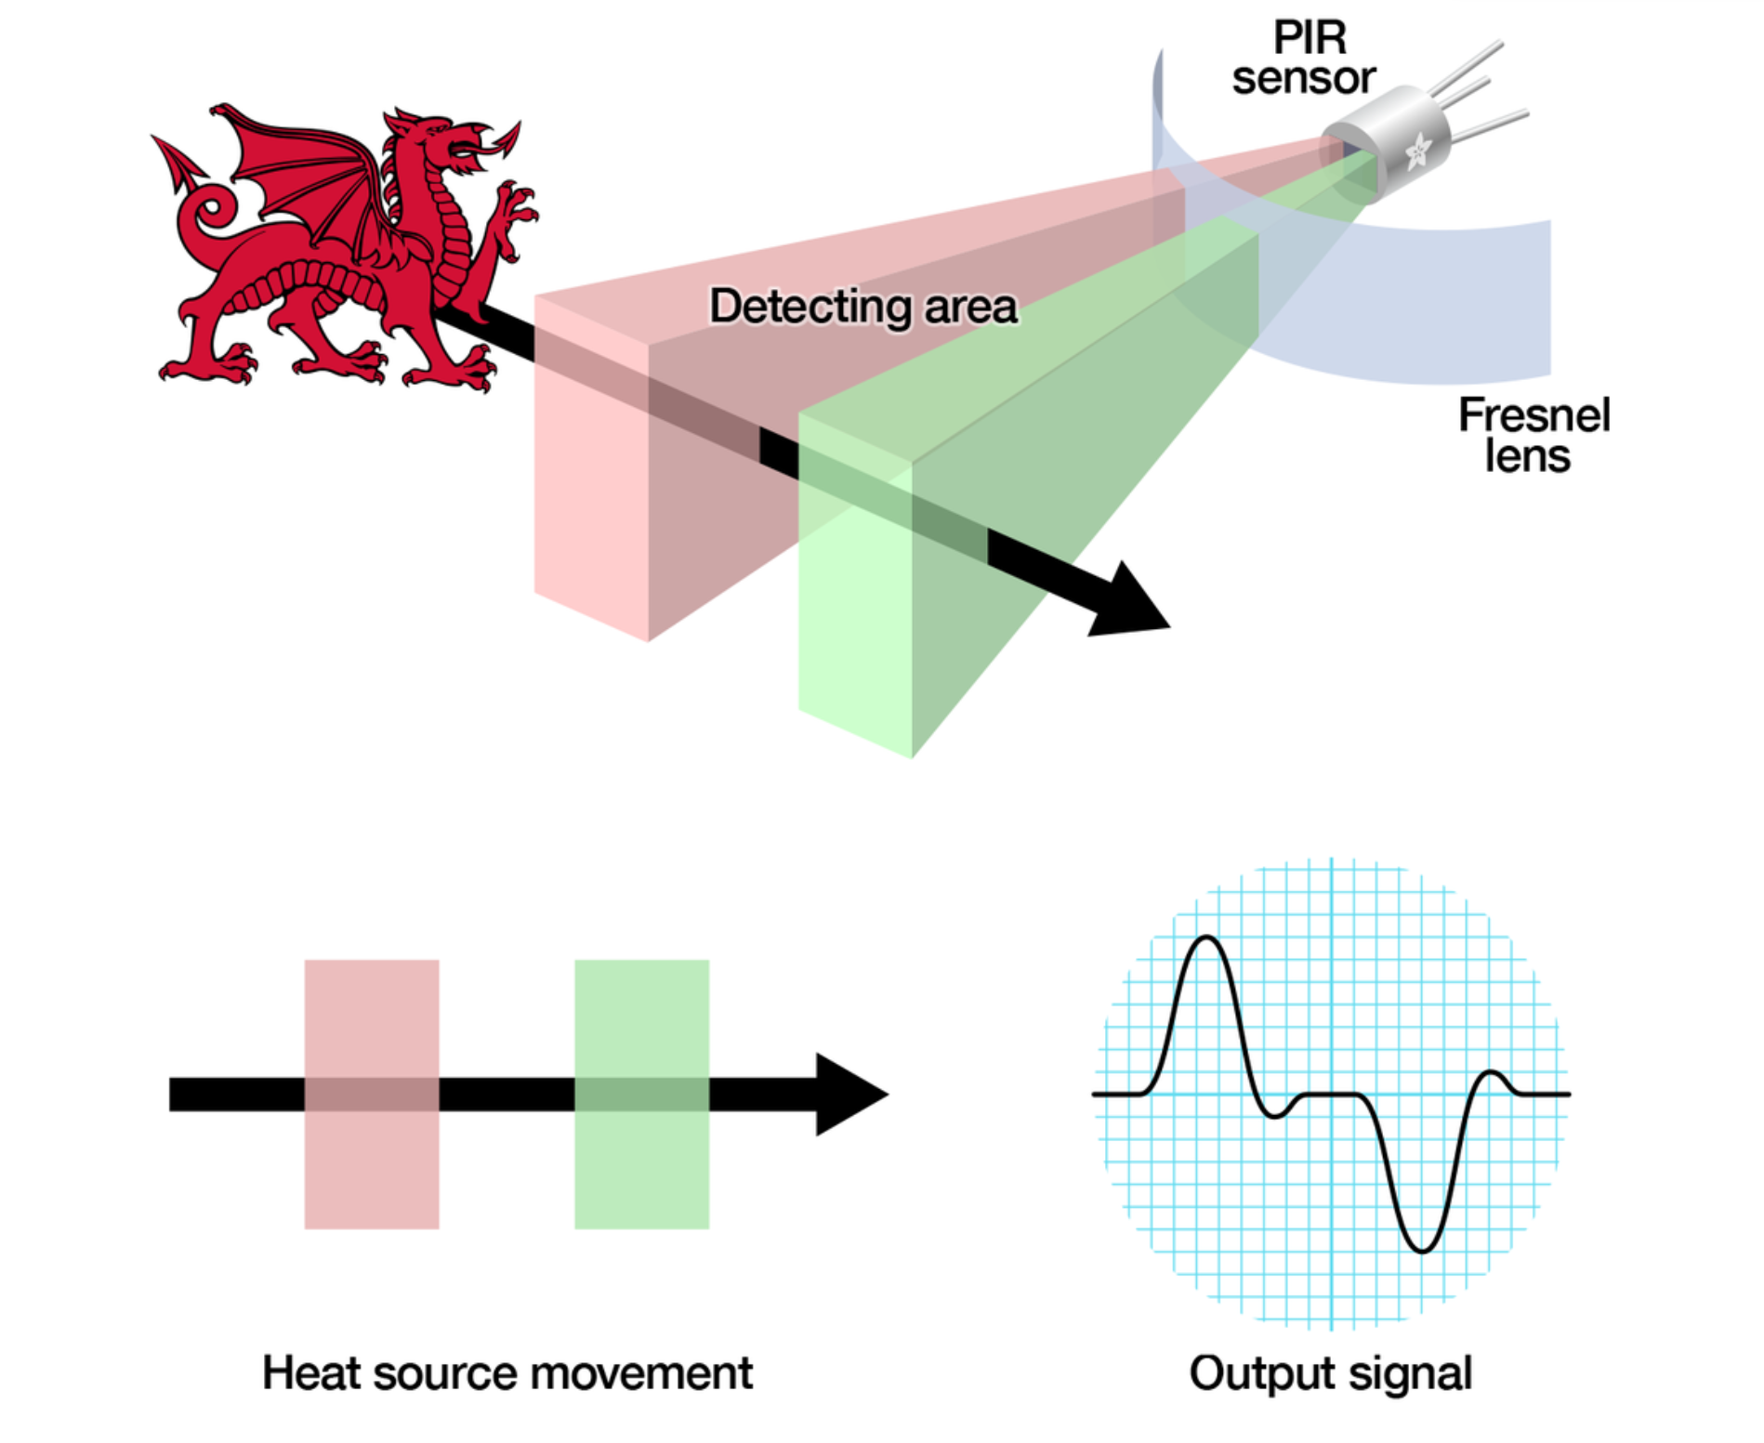

A.8 Why must the value of the resistor R be very high, on the order of 10 giga-ohms?

Answer: Tens of Giga Ohms of resistance is required since the **output current is very small** – in terms of pico amperes, which can **only be read with a very large resistor, creating a significant voltage drop** [**[8]**](https://www.researchgate.net/post/How_much_current_could_be_generated_by_means_of_a_single_piezoelectric_crystal) **.**

A.9 What is the purpose of the fresnel lens in a PIR motion detector?

Answer: Fresnel Lens provides the wider – and useful range to operate upon. It accepts more IR radiation, while focusing it on a small sensitive point to improve the system’s performance [**[9]**](https://www.orafol.com/tl_files/EnergyUSA/documents/PIR%20Lenses.pdf) .

A.10 Why does a PIR motion detector need temperature compensation for changes in ambient temperature?

Answer: Since the PIR motion detector measures the **relative temperature/difference in the temperature between target and the surrounding, if not compensated for temperature then it might not be able to work properly** [**[10]**](https://www.securityinfowatch.com/home/article/10517416/making-sense-of-motion-sensors) **.**

A.11 What is the name of the cat who gets caught by the motion detector in slide 2 of the slide deck C3M4V2.pdf and again in slide 5 of the slide deck C3M4V3.pdf?

Answer: **Oliver**

1. A PIR motion sensor has the following attributes:



What is the voltage across the sensor electrodes in volts? (Type in a three-decimal number)

Answer: **0.054V**

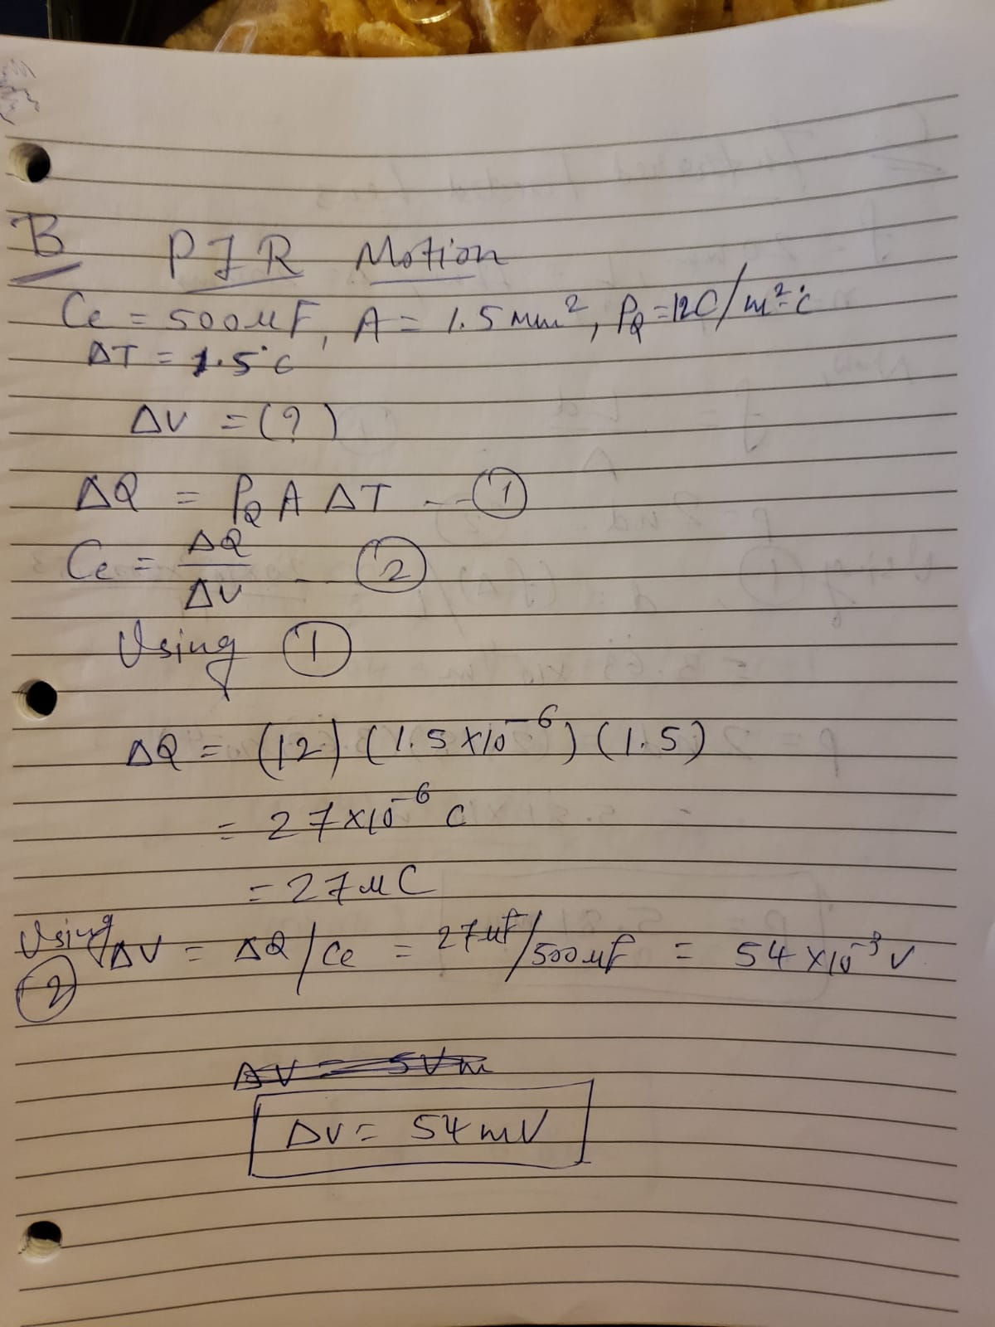

1. An infrared faceted lens is used in a PIR motion sensor designed to protect priceless art in a large museum room. It has the following attributes:



What is the facet pitch of the lens in millimeters? (Type in a two-decimal number)

Answer: **5.81mm**



1. A member of the Mission Impossible team of secret agents crawls into the fortified chamber of enemy headquarters. This chamber is protected by a PIR motion detector mounted on the 8-foot high ceiling above the center of the circular room. The agent starts at the outer most diameter, headed on a radial line for a safe located in the exact center of the room. He wants to steal the contents of the safe, and take this valuable information back to headquarters.

The detector has predetermined protection zones defined by these screen shots below. Miraculously (this is a movie, of course), the agent starts his crawl exactly centered between two of the zone D locations.

Suppose this agent’s body is 1.5 feet wide at his widest point, and he always keeps his arms and legs inside this width.

At what point will the motion detector find him, setting off the alarm and a wild ensuing chase scene in the movie?

(Denote a point on the top view to define your answer, and explain why you think this position is correct.)

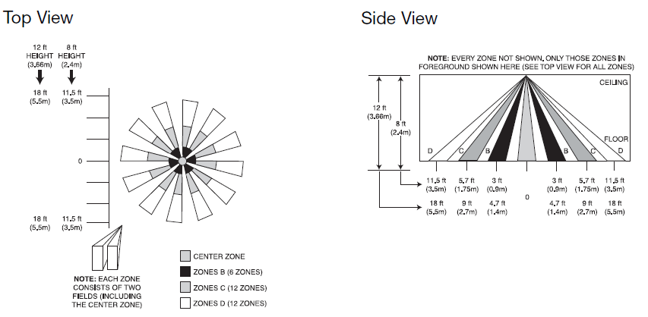



Answer: **At point where Zone C Starts**

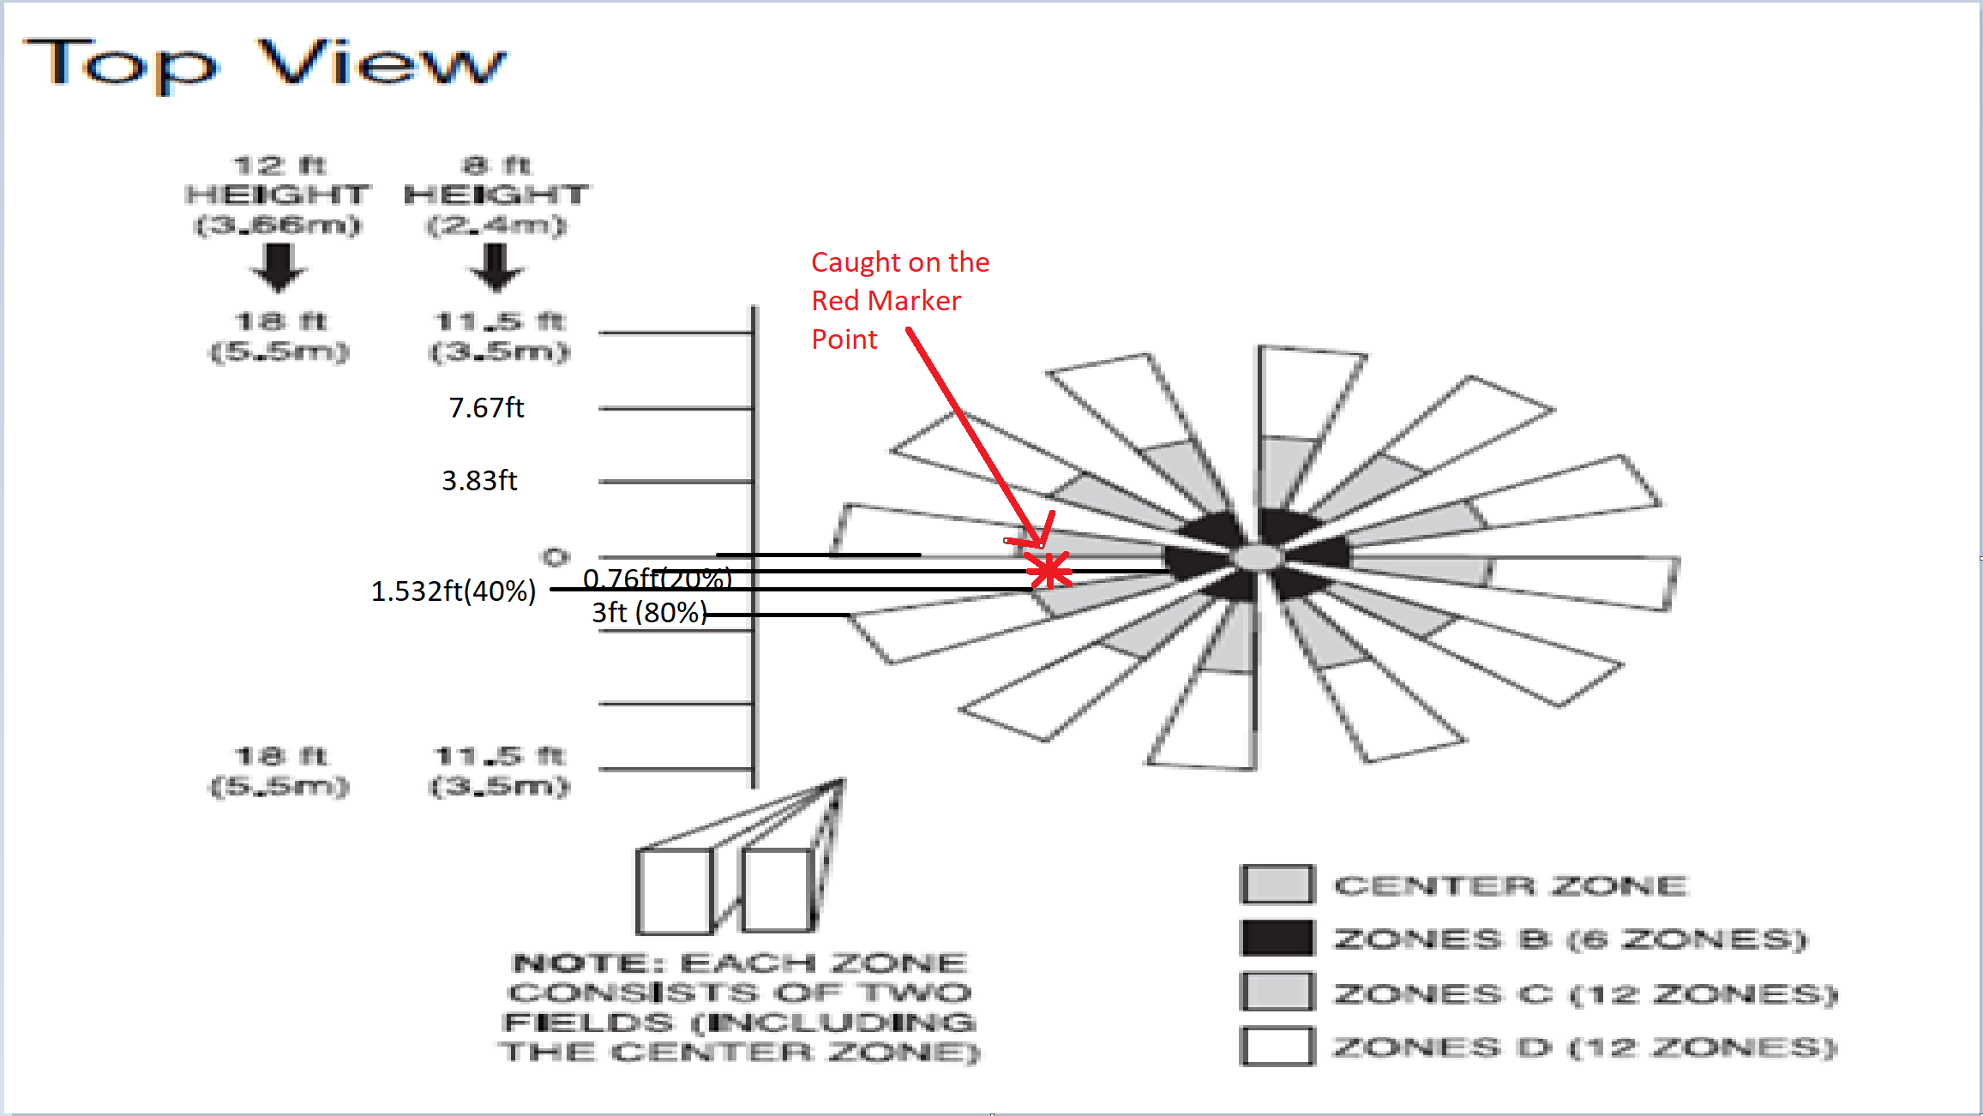

1. Answer the following questions about ultrasonic position detectors.

Reference: [**[11]**](http://www.cypress.com/file/140911/download)

E.1 Why does an ultrasonic position detector have a minimum range?

Answer: A transceiver transducer transmits the sound and receives it. Therefore, **there is a period after transmitting the sound during which the system must wait for the transducer to stop “ringing.” If the system immediately started waiting for the return signal, it would always measure a distance of zero, because it would immediately detect the ringing signal on the transducer. Therefore, the system must wait until the ringing on the transducer has sufficiently diminished for normal signal detection to begin. The waiting time is directly proportional to the minimum detection range distance.**

E.2 What steps would you take to increase the maximum range of an ultrasonic position detector?

Answer: The maximum detection range mainly depends on the

following factors:

-> The amount of power used to drive the transducer, therefore **increasing the power to increase range.**

-> The signal gain and signal-to-noise ratio (SNR) of the circuit used to measure the return signal, **therefore improving the SNR**

-> The properties of the transducer itself.

-> In general, if you need a large maximum range, then **maximize the signal-driving power, the signal gain, and the SNR, and choose a transducer with lower ultrasonic resonant frequency** (30 kHz to 50 kHz), **good receiver sensitivity** (>-70 dB), **higher transmitting sound pressure level** (>120 dB), **maximum input voltage range** (>120 Vpp).

E.3 Why is the power amplifier needed in this circuit for an ultrasonic parking assist system shown in the block diagram below.

Answer: The power amplifier **converts the logic-level square wave generated by the MCU into a signal with much greater power**. This conversion is **necessary because** the generalpurpose input/output (GPIO) pins of **typical MCUs cannot drive high-voltage or high-current signals**. Therefore, a power amplifier circuit is **needed to deliver maximum power to the transducer**. Typically, the power amplifier circuit uses the battery voltage of the vehicle and voltageboosting circuit to amplify the power driven to the load.

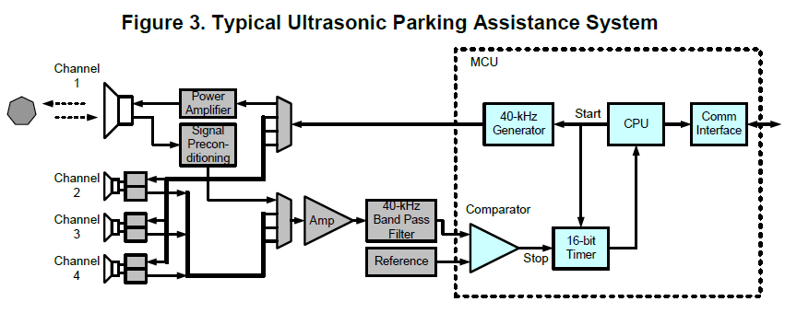

E.4 Why does an ultrasonic position detector measure the ambient air temperature and use it to perform temperature compensation?

Answer: Since the **speed of sound is dependent on the ambient temperature, without temperature compensation – a ultrasonic position detector could give off erroneous readings.**



E.5 What compensation does an ultrasonic position detector perform during echo processing?

Answer: **After transmission, the detector would wait for some time before the echo detection is triggered. This compensation is performed to take into the account the effect of transducer response time. Additionally, the gain of the analog signal chain can be updated dynamically.**

E.6 Why is a piezoelectric sensor used to both transmit and receive the ultrasonic waves?

Answer: Piezoelectric material **exhibits both – to generate voltage when external pressure is applied, and to vibrate when a voltage is applied to it**. This **removes the need to integrate two different instruments in a ultrasonic motion detector**, and therefore a piezoelectric sensor is used for both transmitting and reception of ultrasonic waves.

E.7 What is the difference between pulsed mode and continuous mode operation? What applications exemplify these modes of operation?

Answer:

**Continuous Mode: Measure amplitude of a waveform.**

**Applications: Counter Systems (such as Parking Meters)**

**Pulsed Mode: Measure reflection time of a pulse.**

**Applications: Automatic Traffic Signals, Automatic Doors**

1. An ultrasonic transducer and receiver are located off axis from a direct line to the target. Other aspects of the setup and object detection are shown below:



What is the perpendicular object distance? (Type in a one-decimal number)

Answer: **6.8m**



1. Answer the following questions about microwave detectors.

G.1 Why can’t you use a microwave detector to sense a close-up object?

Answer: After transmitting, the **microwave sensor has to wait for some fixed time before starting to look for echo back.** Because if it doesn’t then it will always detect 0 distance**. Due to this, there is a limit to the minimum detectable distance.** Additionally, the **radiation pattern of the microwave detector prevents it from detecting a close-up object.**

G.2 In what applications are Gunn oscillators used?

Answer: Reference – [**[12]**](https://www.elprocus.com/gunn-diode-working-characteristics-and-its-applications/)

**Applications**

* Gunn oscillators are used for **radio communications, military and commercial radar sources.**
* Used as sensors for **detecting trespassers**, **to avoid derailment of trains.**
* Used as efficient **microwave generators** with a frequency range of up to hundreds of GHz.
* Used for **remote vibration detecto**rs and rotational speed measuring **tachometers**.
* Used as a **microwave current generator** (Pulsed Gunn diode generator).
* Used in **microwave transmitters** to generate microwave radio waves at very low powers.
* Used as fast controlling components in microelectronics such as for the **modulation of semiconductor injection lasers**.
* Used as **sub-millimeter wave applications** by multiplying Gunn oscillator frequency with diode frequency.
* Some **other applications** include door opening sensors, process control devices, barrier operation, perimeter protection, pedestrian safety systems, linear distance indicators, level sensors, moisture content measurement and intruder alarms.

G.3 How is the semiconductor structure of a Gunn diode different from that of a typical semiconductor device?

Answer: In contrast to a typical semiconductor device – which contains both N type and P type material, a **Gunn Diode only contains N Type of semiconductor material** [**[13]**](https://www.radio-electronics.com/info/data/semicond/gunndiode/gunndiode.php) **.**

G.4 How does the structure of the Gunn Diode guarantee that only electrons will be charge carriers?

Answer: **By using only N Type of semiconductor material for construction** [**[14]**](https://www.elprocus.com/gunn-diode-working-characteristics-and-its-applications/) **.**

G.5 Why does current through a Gunn diode increase when voltage is applied across the anode and cathode?

Answer: **Since it is only made up of N Type semiconductor, the whole diode is nothing but Active Region when the operation starts. Therefore, as the voltage is applied, the current starts increasing.**

G.6 What is the region of the Gunn diode I-V curve between the Peak Point and the Valley Point called? What happens operationally in this region?

Answer: The I-V curve between the peak point and the valley point is called **Negative Resistance Region. The current in the diode decreases with the increase in the voltage while in this region** [**[15]**](https://www.radio-electronics.com/info/data/semicond/gunndiode/transferred-electron-device-operation-theory.php) **.**

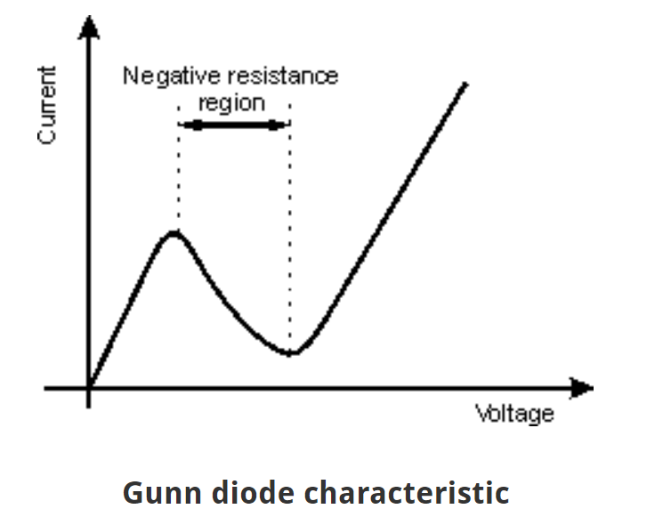

G.7 How would you calculate the dynamic resistance of a Gunn diode in series with the resonator load?

Answer: **Average negative resistance of the Gunn Diode becomes equal to that of the resonator load. This would go a long way in measuring the dynamic resistance of the Gunn diode, since it is the ratio of difference in input voltage to the change in diode current** [**[16]**](http://www.iitg.ac.in/engfac/krs/public_html/lab/ee442/19.pdf)**.**

G.8 The negative dynamic resistance characteristic of the Gunn diode is admittedly odd. Why does it not violate the principle of Conservation of Energy?

Answer: **The oscillations in the negative resistance region are powered by the DC power (such as battery). Since the Diode never reaches 0 volts while in this region, rather stops at a point with some positive potential (called valley point), along with the fact that this is observed in only portion of the AC cycle – the principle of energy conversation is not violated** [**[17]**](https://www.testandmeasurementtips.com/meaning-measurement-negative-resistance/) **.**

G.9 How are the current oscillations initiated in a Gunn diode?

Answer: **Oscillations are initiated when the negative resistance of the Gunn Diode is a bit lesser than that of the loading resonator.**

G.10 How does a Gunn oscillator work to obtain the velocity of the target?

Answer: **Utilizing the concept of Doppler Shift.** The Gunn Oscillator transmits high frequency waves, which changes its frequency when they’re reflected by a moving target.

G.11 Why do you need to run the signal for the doppler shift frequency through both an amplifier and a notch filter in a commercial microwave detector?

Answer: **Amplifier because the shift could be very tiny, hard to detect in raw form. Notch filter to remove errors due to atmospheric particles.**

G.12 Why is bi-directional sensitivity an important feature in commercial microwave motion detectors? How is it implemented?

Answer: **Since bi-directional sensors can detect motion happening in both ways – moving away and towards the sensor – it can be used in a variety of applications. To implement it, a two sided antenna is used along with the sensor – so that just by covering 180° - it can actually have sensing in whole perimeter - 360°.**

G.13 What microwave band is used in the commercial microwave detector shown in slide deck C3M4V5.pdf?

Answer: **K Band (24.15GHz)**

1. A microwave detector is being used as an automatic door opener for the front lobby of a hotel. The following information is known about the detector when sensing a person about to enter the hotel.



How fast is the person moving in m / s? (Type in a two-decimal number)

Answer: **0.559m/s**

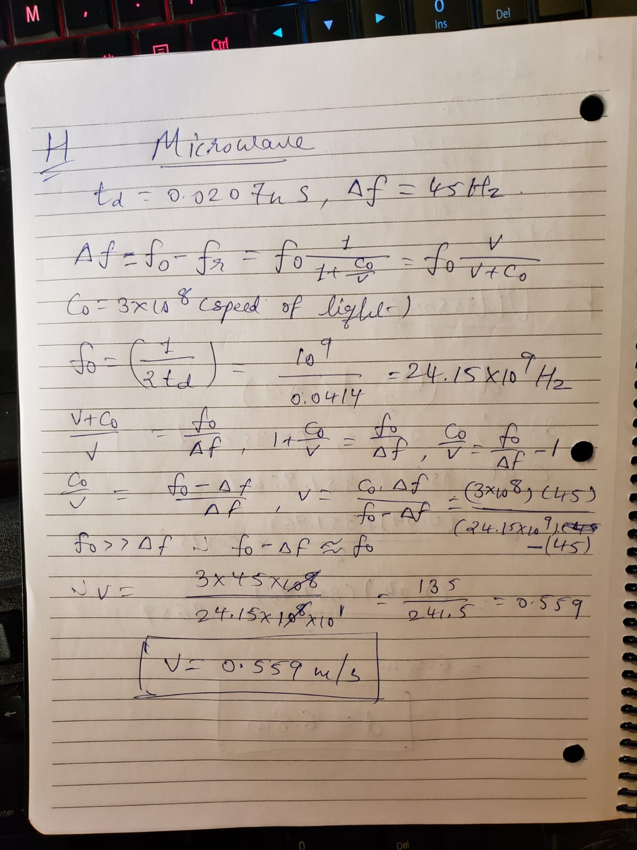

1. A security company would like to use a microwave detector to help protect the home of their billionaire client. He lives reclusively in a villa on top of a mountain, where only one road leads to the top.

The company wants to point the detector at an open point on the road, where they are guaranteed to spot a moving vehicle moving ahead. They want this open point to be sufficiently far away, so that they can have time to alert their security guards to the possibility of an incoming threat.

The following information is specified about the detector when sensing a vehicle on the open point on the road. The security company wants your firm to design the microwave detector.



What is the reflected power, Pr from the vehicle in milliwatts. (Type in a 3-decimal number). Do you think this will be a difficult electronics design to implement in the detector?

Answer: **0.0000042mW (4.2pW), it will be a difficult design since the received power is very small.**

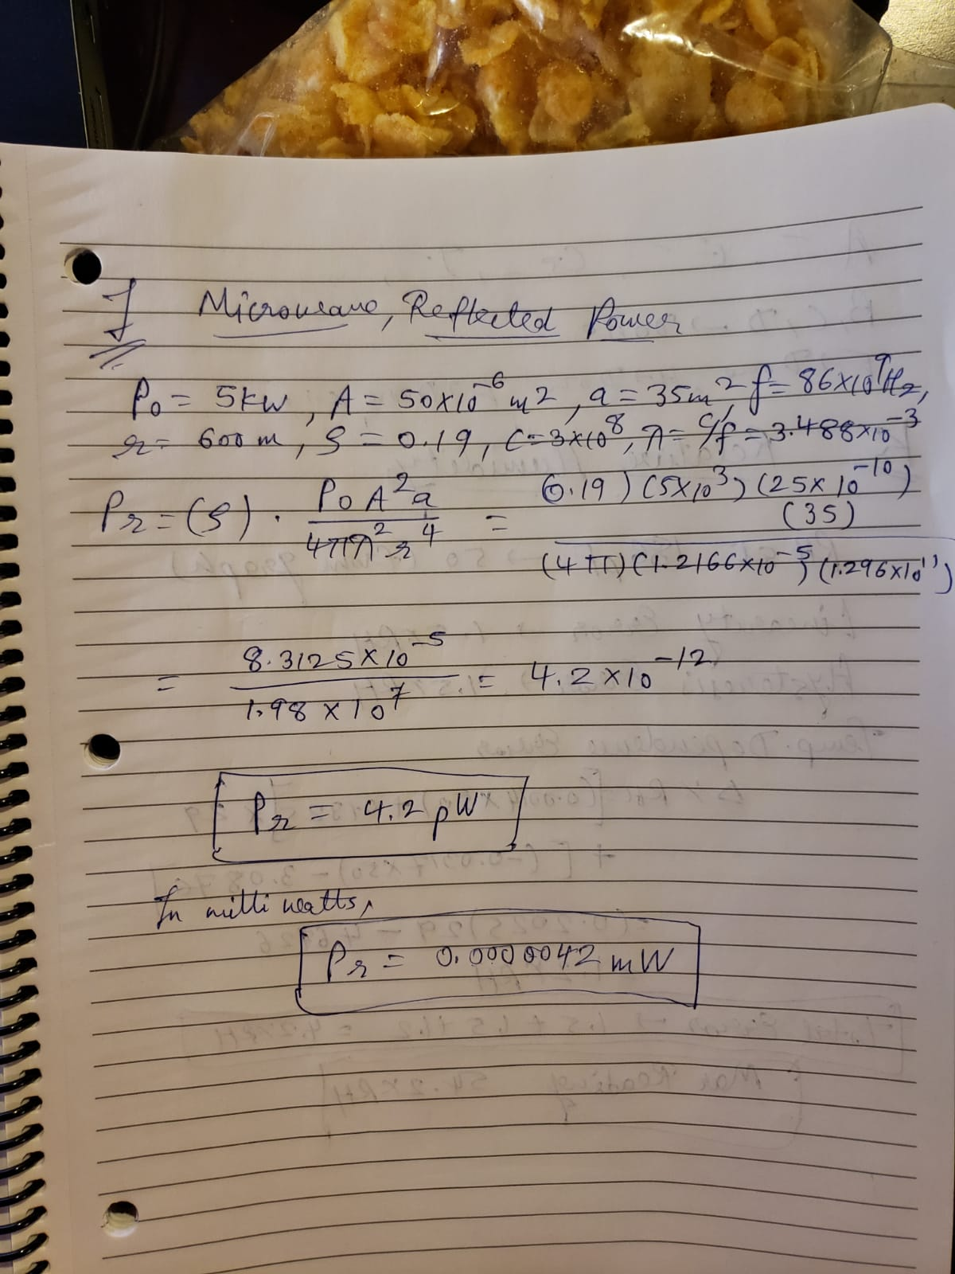

1. Answer the following questions about humidity sensors.

J.1 What is the difference between Ps and RH?

Answer: Reference – [**[18]**](http://kiwi.atmos.colostate.edu/cmmap/learn/clouds/svp.html) [**[19]**](https://science.howstuffworks.com/nature/climate-weather/atmospheric/question651.htm)

**Ps** - **The saturation vapor pressure:** It is **the pressure of a vapor when it is in equilibrium with the liquid phase**. It is solely dependent on the temperature. As temperature rises the saturation vapor pressure rises as well.

**RH – Relative Humidity: Relative humidity is the ratio of the current absolute humidity to the highest possible absolute humidity (which depends on the current air temperature).** A reading of 100 percent relative humidity means that the air is totally saturated with water vapor and cannot hold any more, creating the possibility of rain.

J.2 What is the difference between Patm and Pa?

Answer:

**Patm – Atmospheric Pressure: Pressure of open air in the atmosphere (varying by elevation)**

**Pa – Partial Pressure of Dry Air: Pressure that doesn’t take into the account the pressure due to water vapor.**

J.3 Suppose you cool moist air to the dewpoint. What is the relationship between Pw and PS?

Answer: **If moist air is cooled to the dewpoint, then Pw will reach to zero, making Ps a constant – and only containing the pressure due to dry air.**

J.4 How does relative humidity relate to absolute temperature?

Answer: **Relative humidity is the ratio to present moisture in the air to the maximum pressure the air can contain at that specific temperature. Since the latter increases with the increment in temperature, Relative humidity varies inversely to the temperature (if moisture amount is same).**

J.5 What is one common method of calibrating humidity sensors? How does this method work?

Answer: The method is known as **Saturated Salt Method.** Saturated salt **solutions that hold specific RH levels are placed in small well sealed plastic containers**. The **lids** of the containers are **fitted with a Gortex window that allows vapor exchange but prevents liquid spills and salt migration**. This small container is then placed in a larger container that can hold several loggers. The RH of salt solutions can be affected by temperature fluctuations so it is best if the temperature is as constant as possible. Therefore, it is placed in a gasketed cabinet in a climate controlled store room. **The loggers, set to take readings every two minutes, are placed sequentially in each chamber for two-three days, moving from low to high RH. At the end of the monitoring period the data is downloaded and any which show values outside the expected range of accuracy are sent back for refund or recalibration as necessary** [**[20]**](http://www.conservation-wiki.com/wiki/Calibration_of_Dataloggers_Using_Saturated_Salt_Solutions) .

J.6 How does a capacitive humidity sensor work? What are the advantages and disadvantages of this design?

Answer: A capacitive humidity sensor **measures relative humidity by placing a thin strip of metal oxide between two electrodes. The metal oxide’s electrical capacity changes with the atmosphere’s relative humidity** [**[21]**](https://electronicsforu.com/resources/electronics-components/humidity-sensor-basic-usage-parameter)[**[22]**](http://www.rfwireless-world.com/Terminology/Advantages-and-Disadvantages-of-humidity-Sensor.html) **.**

**Advantages:**

**➨Can withstand below temperature of 0°C**

**➨It does not require any maintenance for longer periods**

**➨Flexibility to use**

**➨Atm. pressure independent, it works when pressure is being applied**

**Disadvantages:**

**➨ It has limited long term stability.**

**➨ It is sensitive to dewing and certain aggressive substances.**

J.7 How does a resisitive humidity sensor work? What are the advantages and disadvantages of this design?

Answer: Resistive humidity sensors **utilize ions in salts to measure the electrical impedance of atoms. As humidity changes, so does the resistance of the electrodes on either side of the salt medium** [**[23]**](https://electronicsforu.com/resources/electronics-components/humidity-sensor-basic-usage-parameter)[**[24]**](https://www.rotronic.com/media/productattachments/files/w/e/webinar_2_v4_-_pros_cons_of_humidity_measurement_technologies_-_9-17.pdf) **.**

**Advantages:**

**➨Field replaceable without calibration**

**➨Inexpensive**

**➨Good for mid-range RH (20% to 90%)**

**Disadvantages:**

**➨ Not suitable for extremes**

**➨ Not resistant to harsh conditions**

**➨ Questionable repeatability**

**➨ Can’t tolerate condensation**

J.8 Why did air filled capacitive humidity sensors never gain commercial acceptance?

Answer: Air Filled Capacitive Humidity Sensors have a **limitation in the length of cable that it can be connected via to the main controller. This is because the changes in capacitance is quite lower than that of the longer cables. Practically, this is just about a few feet, which is impractical, and therefore they never gained the commercial acceptance.**

J.9 What is the relationship between the capacitance of a capacitive humidity sensor and relatively humidity?

Answer: As relative humidity changes, **the Dielectric Constant changes, which results in the change of capacitance at specific humidity. Capacitance and Relative humidity has a linearly proportional relationship** [**[25]**](https://www.rotronic.com/en-us/humidity_measurement-feuchtemessung-mesure_de_l_humidite/capacitive-sensors-technical-notes-mr) **.**

J.10 What is the relationship between the impedance of a resistance humidity sensor and relatively humidity?

Answer: **There is an inversely proportional relationship between the impedance of the resistive humidity sensor, and the relative humidity itself.**

J.11 How is linearization performed for the CHS series of resistive humidity sensors?

Answer: In the CHS Series humidity sensor units, **a frequency that changes according to the humidity obtained by the Z-f conversion circuit is converted into a pulse wave with the pulse width τ**. When doing so, **control of the negative feedback time constant is performed using a nonlinear element to make the pulse width τ large at low humidity or small at high humidity**. As a result, **the exponential characteristic as shown in the graph of Figure 6 (left) is logarithmically compressed and becomes an output voltage characteristic as described in the graph of Figure 6 (right)** [**[26]**](https://product.tdk.com/info/en/products/sensor/sensor/humidity/technote/tpo/index.html) **.**

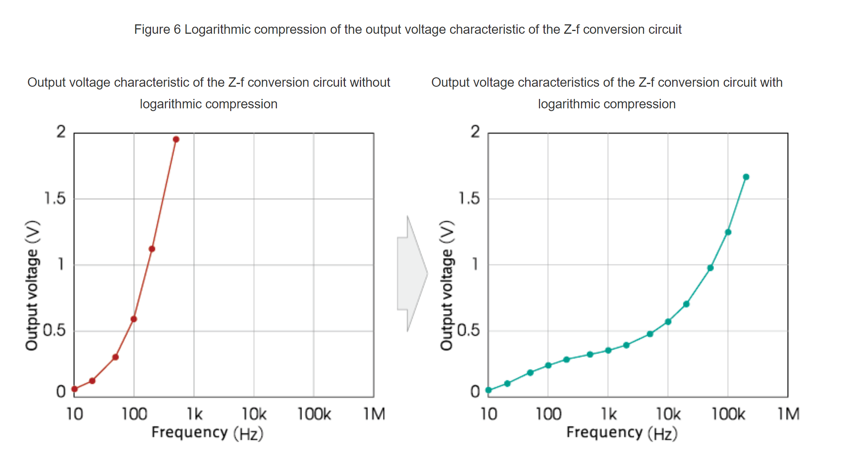

1. You are using the SMD version (surface mount) of the P14-W capacitive humidity sensor from Innovative Sensor Technology Inc. The relevant specs are shown in the screen shots below. Other relevant information is given in the table below



Including the errors associated with linearity, hysteresis, and temperature dependence of the humidity reading, what is the highest humidity reading that you could get? Assume that you sum the errors. (Type in a 1-decimal number).

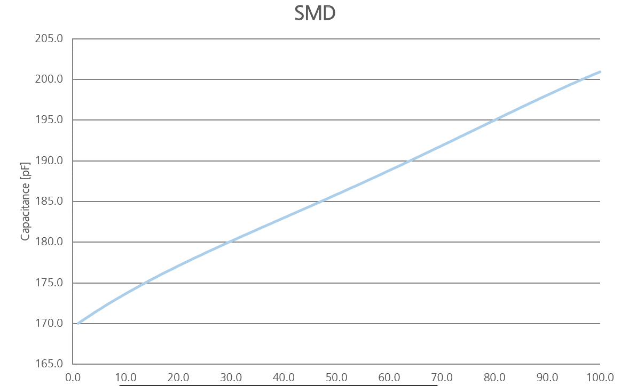

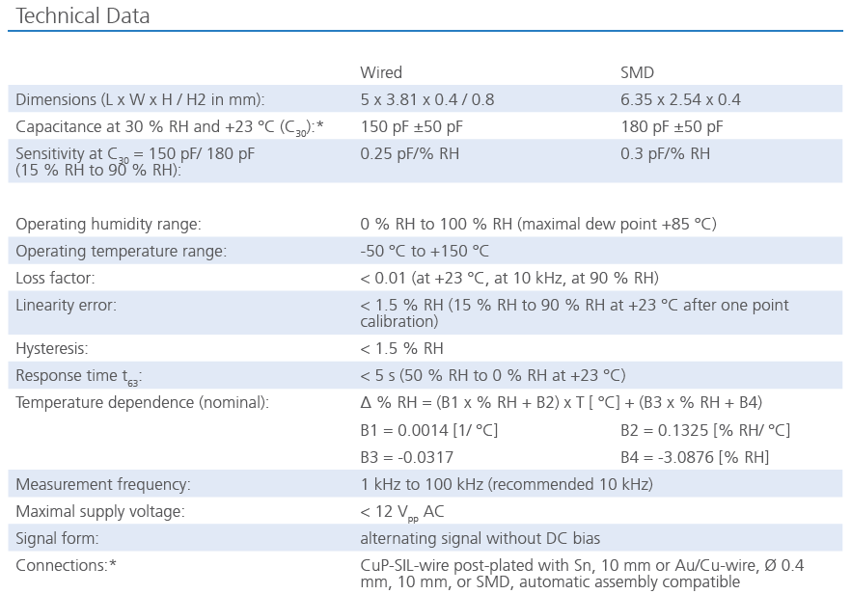

Answer: **54.2%RH**

